Name: ____________________________ Block: ______ Date: ________________________

**NAPOLEON IS ON INSTAGRAM**

[](http://www.google.com/url?sa=i&rct=j&q=instagram&source=images&cd=&cad=rja&docid=x_MIFqLqlLb4uM&tbnid=tC_i4izmmoDhqM:&ved=0CAUQjRw&url=https://itunes.apple.com/us/app/instagram/id389801252?mt=8&ei=2vs6Up_XGo_I9gSr44C4AQ&bvm=bv.52288139,d.eWU&psig=AFQjCNHwRjDoLIU6nFira2YkG6GZCqIB6g&ust=1379683664752663)Instagram is a form of social media to update statuses of personal individuals through pictures, comments, and hashtags. People usually discuss their current day-to-day status with pictures and brief expressions or terms known as “hashtags.” You will create two Instagram postings as a French citizen during the Napoleonic Era on the back and will explain those posts at the bottom of this page.

[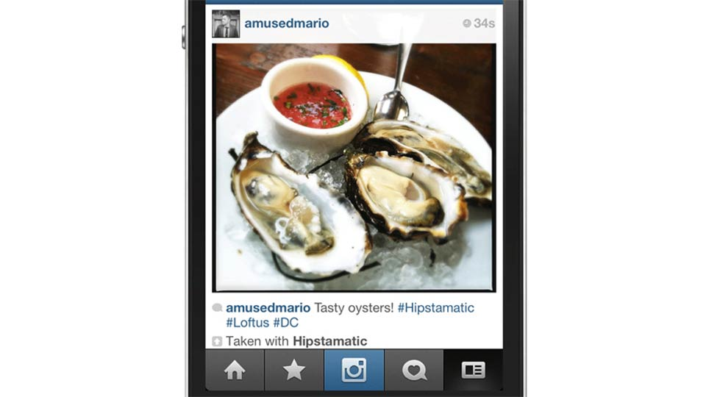](http://www.google.com/url?sa=i&rct=j&q=instagram%20posts&source=images&cd=&cad=rja&docid=hHQaOgJZ291GyM&tbnid=SmORpDTtIA7OJM:&ved=0CAUQjRw&url=http://gizmodo.com/5895152/you-can-post-photos-to-instagram-with-hipstamatic-now&ei=Zvw6UsnQGIqG9QSPi4HgBQ&bvm=bv.52288139,d.eWU&psig=AFQjCNEGTBYIsfm4L9XAh1WV_z9yq8JGKA&ust=1379683804726533)**Directions:** Napoleon had a tremendous influence on the empire and people of France. You will create two status postings: 1) Focus on an event **early** in the Napoleonic Era and how it has affected you. 2) Focus on an event from **later** in the Napoleonic Era and how it has affected you.

Each post must include:

* Your Instagram handle and profile picture
* A screen shot of your account
* Brief post and hashtags by you
* Posts/Hashtags from other people

In the area provided below, please give a 5 sentence minimum explanation on each post. Underline the EVENT and explain how it impacted France back then. You are writing from the perspective of YOU (a modern day high school student in the US). On the back you will (in color) illustrate your “screen shot” of your Instagram account.

Your explanation of Post 1 - Your explanation of Post 2-